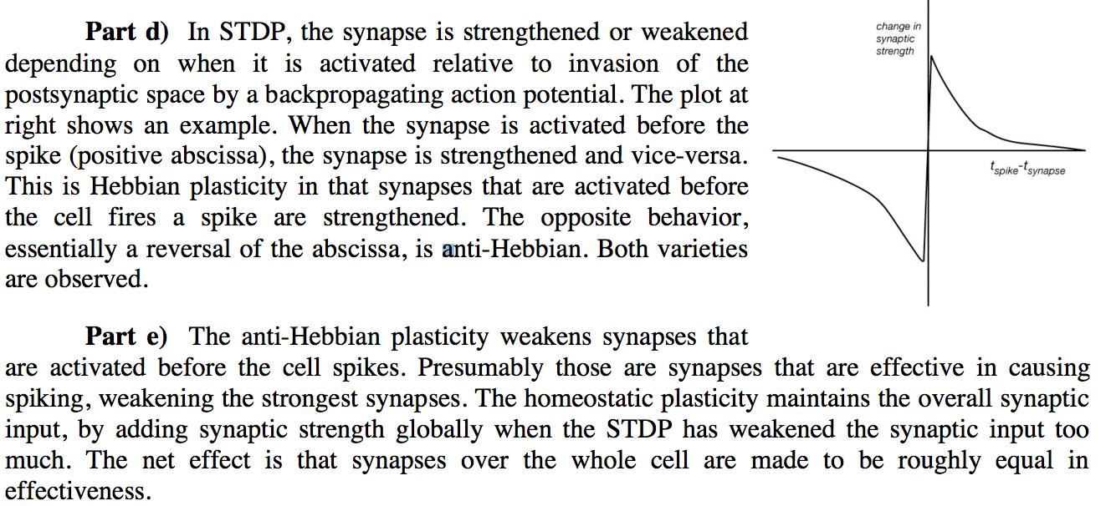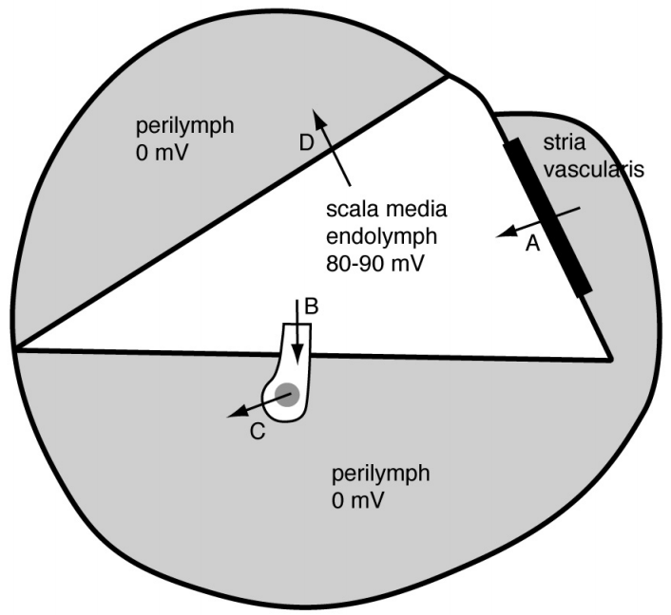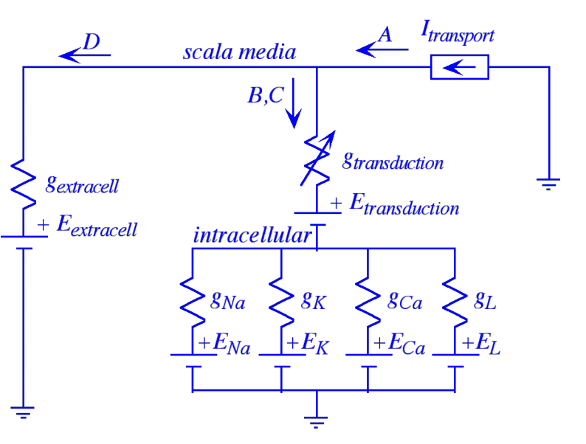

**Ionotropic** receptors contain a channel that is directly gated open by activating the receptor.

**Metabotropic** receptors are coupled to a second-messenger system, like a G-protein, that indirectly affects other cellular processes, which can include opening or closing ion channels.

*Ionotropic pass an ion, metabotropic pass a message*

NMDA receptors are ionotropic. They differ from most other ionotropic channels by being conditionally gated through a Mg-block mechanism so to conduct ions, there must be neurotransmitter (glutamate) present and depolarization of the postsynaptic membrane.